**Contents**

2. Environmental impacts of future EGD scenarios 1

2.1 Integrated environmental assessment based on the Consumption Footprint 1

Consumption perspective and effects in global supply chains: the need for a holistic approach 1

Methodology of the integrated environmental assessment of future EGD scenarios 4

Consumption Footprint in 2030 7

Why is this important in driving EU competitiveness and innovation 10

Key messages 11

2.2 Synergies and trade-offs of environmental impacts across EGD thematic areas: key examples 11

Raw Materials 11

Land use 14

Circular economy and climate mitigation 15

References 19

Annex 22

Overview of the targets modelled in the Domestic Footprint Outlook 22

Overview of the targets modelled in the Consumption Footprint areas of Consumption 22

Mobility 23

Food 23

Housing 24

Cross cutting: energy, transport, waste treatment, recycling and packaging 24

1. Environmental impacts of future EGD scenarios

To assess the expected impacts of the EGD, an integrated approach accounting for multiple environmental impact categories and by adopting a full supply chain perspective is needed. To this end, an integrated environmental assessment based on the life cycle assessment Consumption Footprint and Domestic Footprint models allows to get first insights of the expected environmental impacts of possible green transitions scenarios by 2030.

The exercise considers **selected EGD targets and ambitions**, with focus on physical environmental indicators (section 3.1; see Annex of this chapter for details). The analysis is instrumental to show the importance of considering synergies and trade-offs across areas of consumption and environmental impacts. This exercise is complemented by zooming in on selected key examples concerning raw materials, land use and circular economy (section 3.2).

* 1. Integrated environmental assessment based on the Consumption Footprint
     1. Consumption perspective and effects in global supply chains: the need for a holistic approach

Environmental impacts of products need to be evaluated in an integrated manner along their whole supply chains and including the **entire life cycles** of products, from resource extraction, manufacturing, use, and waste generation. This can be done with quantitative systemic impact assessment methodologies such as **Life Cycle Assessment** (LCA) [1]. Through this approach, potential **trade-offs among environmental impacts, life cycle stages of products, economic sectors or geographical regions** can be identified, **thus enabling prevention strategies to avoid burden shifting of impacts**. For instance, an improvement in energy efficiency in the use phase of a product may require more raw materials extracted elsewhere in the value chain [2].

**Figure 1.** Overview of life cycle stages from raw materials to end of life, including alternative end of life pathways according to Circular Economy strategies.

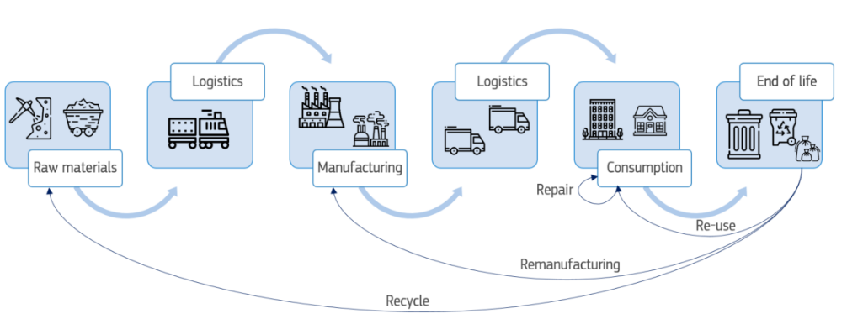

Source: [3].

To perform environmental integrated impact assessments, specific models can be designed to exploit the power of data at the EU level and provide sound evidence support to policy. The **Environmental Footprint (EF)** is the LCAmethod recommended by the European Commission. It takes into account 16 environmental impact categories on air, water, land, resources and toxicity[1].

Relying on this method, the JRC developed a modelling framework composed of two simulation models analysing EU environmental impacts by adopting complementary perspectives. The **EU Consumption Footprint (CF) model** considers 164 representative products across their **international supply chains** to calculate the environmental impacts associated EU consumption for five main areas, namely food, mobility, housing, household goods and appliances. In addition, the **EU Domestic Footprint (DF) model** adopts a **production** **and territorial-based perspective** to assess the environmental impacts associated to emissions and resource extraction occurring within a Member State boundary, up to the whole EU. For both models, the resulting environmental impacts are derived according to the 16 impact categories of the EF method. These can also be aggregated as a single weighted score indicator, which is currently used for monitoring in different EU policy frameworks. These include the 8th Environmental Action Programme [4], the Zero Pollution Action Plan [5], the EU Sustainable Development Goals monitoring framework [6], the EU Circular Economy monitoring framework [7], the Resilience Dashboard [8], and the EU Food System Monitoring Dashboard [9]. Data are available in the European Platform for Life Cycle Assessment (EPLCA) [10].

One important strength of the CF and DF indicators is that they can be compared with the planetary boundaries framework. **Planetary boundaries** are the safe self-regulating environmental limits[2] for human pressures which together maintain a stable and resilient Earth. The EU’s **Eighth Environment Action Programme** (8th EAP) calls for the EU to significantly reduce by 2030 its consumption footprint, and to **bring it within planetary boundaries** as soon as possible. In the CF, the 16 EF impact categories have been mapped to the planetary boundaries. Currently, the EU consumption footprint crosses the planetary boundaries for 5 out of 16 EF impact categories (Figure 2): ecotoxicity freshwater is exceeded by 10 times, particulate matter by 9 times, climate change by 8 times, resources use in fossil fuels by 3 times, and minerals and metals by 2 times.

Figure 2: Consumption Footprint impacts and the planetary boundaries

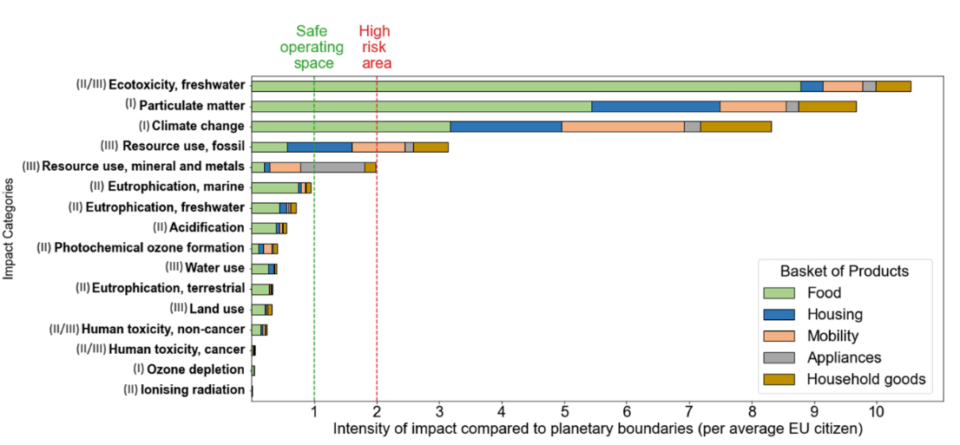

Source: EPLCA [10]. Model robustness between ‘I’ (or high confidence) and ‘III’ (or low confidence) of the impact assessment model used to assess each indicator is taken from [5][3].

Comparing the evolution of the Consumption Footprint (CF) and the Domestic Footprint (DF) in relation to the Real Gross Domestic Product (GDP) per capita of the EU-27 for the period between 2010 and 2022 highlights the increasing role of imports in determining the environmental impact of EU consumption (Figure 3; [11]. Indeed, while the DF shows a continuous decrease (-19%) between 2010 and 2022 across all impact categories, thus indicating an absolute decoupling from economic growth, the CF is instead increasing (+8%). This demonstrates only a relative decoupling of consumption impacts from growth, as CF grows less quickly than GDP per capita (+16% in 12 years, [12]). From this comparison, it clearly emerges to which extent **environmental impacts of EU consumption also occur in third countries.**

In other words, the **reduction of environmental impacts on EU territory is being offset by the delocalized impacts to other world regions** through the supply chain of imported raw materials, intermediary and final products. In this respect, recent pieces of EU environmental legislation have shifted their focus to the EU market rather than to the EU producers, switching from a territorial to a consumption approach, namely by setting product requirements to enter the EU market regardless the origin of production such as the Ecodesign for Sustainable Products Regulation[4] or the Regulation on Deforestation-free products[5].

Figure 3: Evolution of the EU Domestic Footprint and EU Consumption Footprint compared with Gross Domestic Product per capita index (2010=100%), for the period 2010-2022

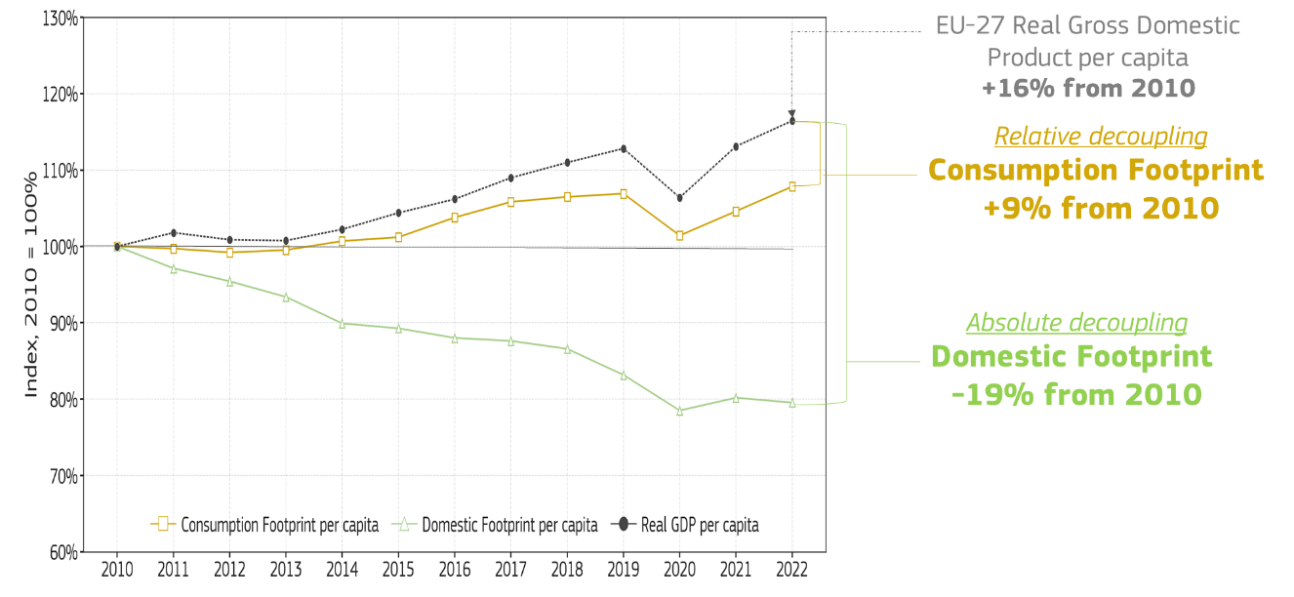

Source: [11].

When disaggregating the Consumption Footprint based on the different areas of consumption, it turns out that most of the environmental impacts of consumption are associated to **food** (Figure 4), which appears to represent 49% of the environmental burden in 2022, followed by housing (17%), mobility (16%), household goods (11%), and appliances (7%). The effects of the COVID-19 pandemic are visible between 2019 and 2020, mainly due to the lower use of transport, which has fully recovered by 2022 **with total environmental impacts having surpassed pre-pandemic levels**.

Figure 4: Contribution of the areas of consumption to the EU Consumption Footprint from 2010 to 2022

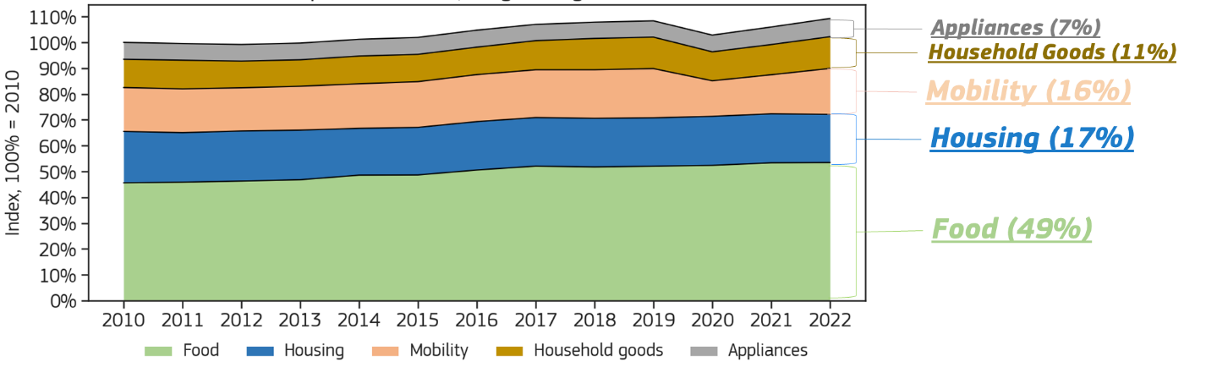

Source: [11].

* + 1. Methodology of the integrated environmental assessment of future EGD scenarios

[13] provided an early assessment of possible progress to achieve EGD targets by 2030. **155 EGD** targets retrieved in both legally binding and non-legally binding policy documents have been classified depending on their progress in three categories:

(1) **on track to be achieved**, if the observed progress follows a positive trend and is expected to be achieved by 2030,

(2) **acceleration needed**, when progress is observed, but this is not sufficient to reach the target by 2030,

(2) **no progress**,i.e. the target is not expected to be achieved, and no positive progress is expected by 2030.

Out of these targets, **a selection of 46 targets** (which named green transition targets GTT from here onwards) were taken into consideration for the present quantitative exercise. These include **33** modelled in the Consumption Footprint model, **18** in the Domestic Footprint models, and **5** targets considered in both models)[6]. In addition, **4 additional ambitions** were included in the CF model assessment as shown in Figure 5 and in Table 1[7]. While some targets could be modelled in the sub-components of the different areas of consumption of food, mobility, and housing, **20** targets were considered as cross cutting, thus covering more than one area of consumption. The Annex of this chapter provides a selection of the targets and ambitions considered.

Figure 5: Overview of the 46 selected green transition targets and 5 additional ambitions modelled in the Consumption and Domestic Footprint models for this integrated environmental assessment

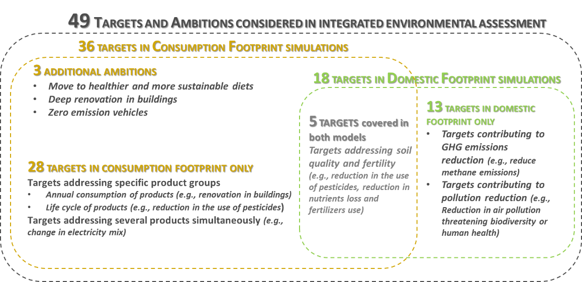

Source: [3].

It is worth noting that, the Consumption Footprint and Domestic Footprint models produce complementary indicators. Specifically, the DF is based on a collection of environmental statistics on EU territory. Instead, the CF model is based on 164 representative products with associated environmental impacts of their whole supply chains. In so doing, some targets can be covered in one model and not in the other, with greater granularity for product oriented targets in the CF model (e.g. housing consumption reduction, but without capturing the climate target as a whole), and with more aggregated targets (e.g. model total GHG reduction without giving conclusion on specific sectors such as housing) using the DF model.

Based on the [13] classification, these targets were progressively included in **three scenarios** that describe increased ambitions in the achievement of GTT objectives. The scenarios are modelled as follows[8]:

* **NO GTT**: this scenario assumes the continuation of existing policy trends before the implementation of the EGD. This scenario provides a reference for the analysis, thus helping to measure the potential environmental benefits that can be achieved by GTT policies.
* **GTT on Track**: this scenario is based on the production and consumption expected trends and considers all the targets assessed as **“on track to be achieved”** by 2030 in the [13] assessment.
* **GTT ambitions**: this scenario expands the scope of the GTT on Track scenario by assuming the full achievement of **all GTT legally binding goals**, including the non-legally binding ones (i.e., from proposals and communications, such as the Farm to Fork Strategy) as well as **further** identified **ambitions** (e.g., a change in food diet).

The comparison between scenarios allows to answer the following questions:

1. What is the expected evolution of the environmental impacts of EU consumption and production by 2030?,
2. How much will the Consumption Footprint change by 2030 if all GTT targets and ambitions are achieved?
3. Which are the most relevant trade-offs across areas of consumption, and environmental impacts, to implement GTT targets and ambitions to 2030?

These three scenarios have been simulated with the CF and DF models.

The drivers of the CF model scenarios are (i) the projections in annual consumption of products by 2030, and (ii) the environmental impacts of products which are modelled at the unit level and can be parametrized to model the achievement (or not achievement) of GTT targets. A combination of model adaptations by editing these drivers for each target underpins the scenario analysis proposed in this chapter. In other words, in the CF, the changes in environmental impacts are driven by a combination of changes in the annual consumption by 2030, and/or changes in the parameters that influence the relationships within life cycle inventory of products.

Table 1: EGD targets and ambitions modelled in this Integrated Environmental Assessment mapped against the Thematic Areas. (draft table)

|  |  |  |  |  |  |  |
| --- | --- | --- | --- | --- | --- | --- |
|  |  | **Areas of Consumption in Consumption Footprint model** | | | |  |
|  |  | **Food** | **Housing** | **Mobility** | **Cross cutting (includes also Household Goods and Appliances)** | **Total targets by TA** |
| **Targets considered in the thematic Areas** | **TA2 – Clean and Affordable and Secure Energy** | - | **4 targets**  (energy use in buildings, renovation wave) | - | **7 targets**  (renewables in the energy mix, wind solar, geothermal energy expansion) | 11 |
| **TA3 – Industrial strategy for a clean and circular economy** | - | - | - | **12 targets**  (recycling material in batteries, recycling of packaging including PET bottles) | 12 |
| **TA4 – Sustainable and Smart mobility** | - | - | **2 targets**  (sustainable fuel in aviation and road transport) | - | 2 |
| **TA5 – Greening the CAP / Farm to fork Strategy** | **4 targets**  (pesticides reduction, food waste related) | - | - | - | 4 |
| **TA6 – Preserving and Protecting Biodiversity** | **3 targets**  (organic farming expansion, fertilizers and nutrient losses reduction) | - | - | - | 3 |
| **TA7 – Towards a Zero Pollution for a toxic free environment** | **1 target**  (reduction in pesticides) | - | - | - | 1 |
| **Additional** | **EGD Ambitions** | **1 ambition**  (sustainable and healthy diets) | **1 ambition**  (achieving deep renovation in buildings) | **1 ambition**  (expansion of electric cars) |  | 3 |
|  | **Total targets by BOP** | 9 | 5 | 3 | 19 | **36** |

Source: own elaboration.

* + 1. Consumption Footprint in 2030

The **Consumption Footprint is far above the planetary boundaries for 5 out of 16 considered environmental impact categories**. However, **GTT policies that are on track have significant positive impacts** to reduce and mitigate additional increases in the other categories despite economic growth, and the achievement of ambitions could support additional benefit to 2030 assessment. **The areas where the greatest opportunity lies appear to be housing and food** while mobility, household goods and appliances are expected to increase their impacts even if GTT ambitions are reached due to increased consumption trends.

***How are trends expected to evolve over time?***

When adopting an EU territorial perspective, the **Domestic Footprint** shows that environmental impacts are decreasing on EU territory for the period 2010 to 2022, and further reduction are expected even in the **NO GTT** scenario thanks to the effects of current macro-economic and political trends including the relocation of industrial plants outside of the EU. These effects are further reduced in the various considered scenarios (see [3] for details).

A different perspective emerges with the Consumption Footprint (Figure 6), which considers the full value chain of products by adopting a consumption perspective. As a result the analysis of this environmental integrated assessment focuses of this area.

Comparing historical and outlook data up to 2030 of the various impact categories of the **Consumption Footprint**, an upward trend is found (Figure 5). In **GTT on track,** a significant decrease is found in 15 out of 16 impact categories, thus demonstrating the clear need of GTT effort was not vane. The effects of achieving **GTT targets and ambitions** provide significant additional contribution to the reduction in environmental impacts. However, the category of mineral and metals resource use would still show a significant increase, with limited impact of GTT efforts in the three considered scenarios.

Figure 6: Consumption Footprint historical data and 2030 outlook in the selected scenarios compared to Planetary Boundaries.

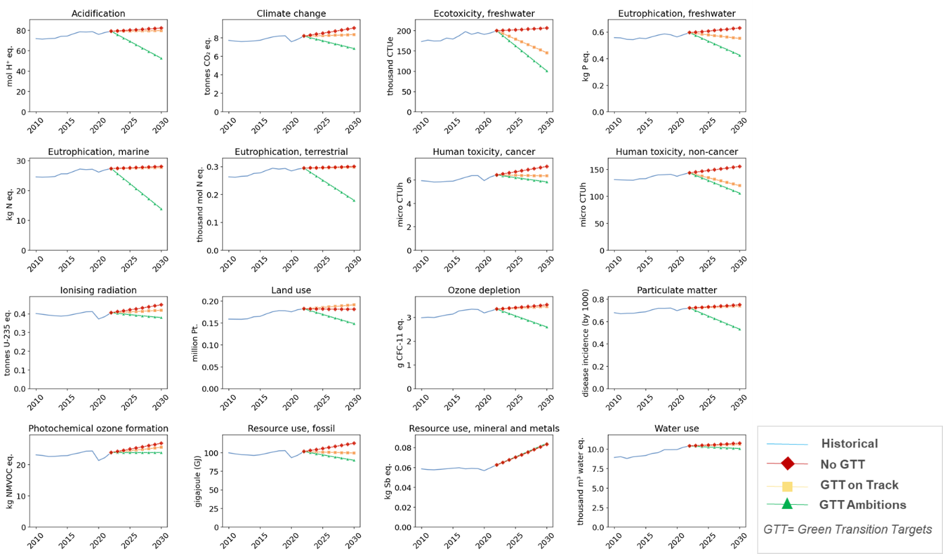

Source: Based on [3].

***How are scenarios expected to perform in 2030?***

If we zoom in the situation in **2030** and compare to the 2022 value (Figure 7), we find that **without GTT efforts** environmental impact tend to increase mainly due to the growth in consumption. This is true for all areas of consumption taken individually and for all environmental impact across all 16 EF impact categories (Figure 6, top left quadrant). The greater concern is in the area of mineral resources use which is expected to rise by +35% in comparison to 2022.

**GTT targets on track** (based on [13]) are expected to reduce impacts in particular for toxicity and eutrophication (i.e., from -8% to -30% with regards to **No GTT**; Figure 6, top right quadrant). Trade-offs are visible for land use and mineral resource use due to the strong influence of the energy transition to renewable energy that would require more land for solar and wind power plants, and increased consumption of motor vehicles and appliances which still require greater consumption in mineral and metal resources. On a positive note, GTT efforts appear to offset the effects of consumption growth of the No GTT scenario, thus supporting decoupling of environmental impact from consumption growth and keep impacts at a similar level to that of 2022.

On the other hand, there is a large additional opportunity in terms of reduction in environmental impacts that could be generated by **achieving all GTT targets** **and ambitions.** This can result in an additional gain up to -50% (as in the case of eutrophication marine), and generally improve from about 5 to 20% for all the other impact categories. The only impact category which remains of concern is **mineral and metal resource consumption** which remains at a similar level in all scenarios (i.e., around +35% against 2022). This indicates that the shift in the energy transition does not reduce the absolute impact that EU consumption may have on minerals consumption.

Figure 7: Comparison of the three scenarios in 2030 with respect to historical values in 2022*.

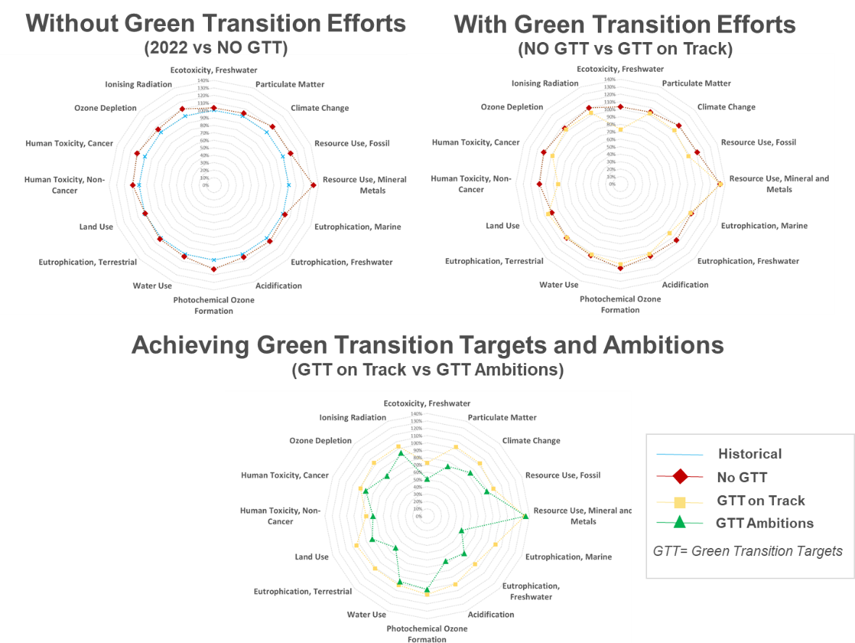

Source: Based on [3]. * Environmental impact in 2022 =100%

***Which are the differences between the key areas of consumption?***

When looking at the different areas of consumption (Figure 8), it turns out that food and housing are the areas where the most of opportunity lies to bring environmental impact towards planetary boundaries, while mobility, appliances and household goods are rather expected to bring their environmental impact up further. Figure 8 proposes these results by area of consumption compared to their relative value in 2022, and in relation to their planetary boundary thresholds. When the contribution to the environmental impact of an area of consumption demands higher impacts, this goes towards the right in the figure. When it the contribution of an area corresponds to lower impacts, it is provided on the left of Figure 7.

In the **NO GTT** scenario (i.e., if no progress was made thanks to green transition policy), the sum of impacts across the CF areas of consumption is expected to demand between 0.5 to 0.8 additional equivalent planets by 2030 in the context of the 5 impact categories that are above planetary boundary thresholds in 2022 (see Figure 2). In the **GTT targets on track** scenario (based on [13]), the achievement of the targets of reduction in pesticides, alone, could be responsible for substantial reduction of the impact in freshwater ecotoxicity. In addition to this, achieving the targets linked to the expansion of solar and renewables in the energy mix in the housing sector can significantly reduce the impact (mainly climate change, fossil fuel resource use and freshwater eutrophication) in the use phase (warming or cooling) of houses. Unfortunately, the final results at the CF aggregated level would result in an increase in the total CF (see both Figure 5 and Figure 6), as the increases in the environmental impact in mobility, appliances and goods would be greater than the reduction obtained by housing.

If we look at the **GTT ambition** scenario, we see the greatest impact of achieving ambitions in **housing** via achieving deep renovation (i.e., reduction in energy consumption in buildings), and, most importantly, in **food** via the change towards a more sustainable and healthy diet[9], alongside achieving the target of expansion of organic farming, and reduction in nutrients loss[10]. The sum of these reductions in food and housing areas could reduce significantly the number of times the planetary boundaries are exceeded for climate change, particulate matter and freshwater ecotoxicity, and also reduce the impact generated by fossil fuel. The only criticality remains on the side of minerals and metals resource use, which is expected to increase by a factor of about 0.8 equivalent planets by 2030, even of all GTT ambitions were to be achieved. Notably, the impact assessment method used for minerals and metals does not take into account material criticality (i.e. considerations related to supply risk or economic importance of the materials) but is based on biophysical resource depletion and potential reduced availability for future generations[11].

It is worth noting that the limited results on the sides of appliances, and household goods, are partially due to the fact that product specific EGD targets are not considered are in [13], and not modelled in the present exercise. These measures, which are specifically addressing circularity economy measures and improved performance of products, could thus further contribute to further reduction of environmental impacts. It should be noted that some of them could however be covered by selected modelled targets (e.g. renovation wave targets modelled in housing, partially consider improved energy efficiency of appliances in use).

Figure 8. Trade-offs between areas of consumption, by comparison NO GTT, GTT on track and GTT ambitions scenarios with 2022 data.

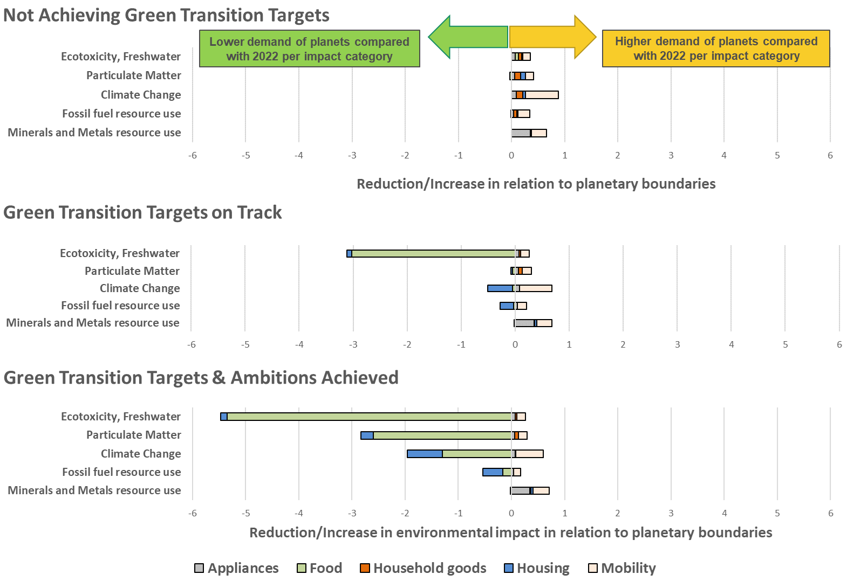

Source: Based on [3]. Note: all data are compared with the planetary boundary threshold per every impact category considered.

* + 1. is this important in driving EU competitiveness and innovation

1. An overall reduction of the environmental impacts of EU production and consumption resulting from the achievement of EGD targets and ambitions can support innovation and competitiveness. Reducing the environmental impacts of EU production and consumption can mitigate the negative effects of consumption growth on competitiveness in two main ways. On the one hand, it can **reduce environmental externalities**, in terms of investment required to mitigate (or adapt to) the negative consequences of environmental impacts (e.g., response to extreme weather events due to climate change) as well as costs of public health due to human health-related diseases (e.g., respiratory diseases due to air pollution). When focusing on decarbonizing the EU system, the implementation of some policy initiatives will have a positive contribution in the short-term, such as the Industrial Decarbonisation Accelerator Act (IDAA) under the Clean Industrial Deal [14] and the Carbon Border Adjustment Mechanism (CBAM) [15], by focusing on product and industry specific situations, such as those of sustainable transport and steel.
2. On the other hand, **improving the sustainability of the EU production and consumption system can reduce dependencies to natural resources** in two main ways. Firstly, making the EU system more resource efficient directly lower the demand of natural resources (e.g., water, critical raw materials, energy and land resources) and associated dependencies from natural resources. Secondly, reducing the impacts of EU production and consumption can decrease current pressure level of environmental burdens on available natural resources, e.g. negative impacts on soil quality reducing the availability of land resources. Overall reductions of dependencies would support stability of the socio-economic system, thus supporting EU towards growth and competitiveness in a digitally driven EU market [16]. Overall, **reducing dependencies on natural resources increases security and strategic autonomy**, which is supported by specific policy initiatives such as the Critical Raw Materials Act [17].
3. Therefore, the positive trends observed in the transition scenarios signal a positive contribution to EU competitiveness. Beyond the scope of this exercise, it is worth noting that **sustainability of production and consumption works in synergy with innovation**. On one hand, moving towards sustainability can drive investments and demand through market differentiation (e.g., being the most sustainable options available in the market). On the other hand, innovation is key to promote sustainability (e.g., R&D) and can generate cascading effects along the entire supply chain. For example, the Ecodesign for Sustainable Products Regulation (ESPR) [18] can promote this shift towards sustainability and innovation in the market.
   * 1. Key messages

While the EU environmental impact is decreasing on EU territory, showing decoupling from consumption growth, the **Consumption Footprint (thus accounting for international supply chain operating also beyond EU boarders) remains far above the planetary boundaries for 5 out of 16 environmental impact categories, and is following upward trends** (ecotoxicity freshwater, particulate, climate change, resources use in fossil fuels, and minerals and metals).

**The ability to revert these trends represents an unprecedented policy challenge.** While the environmental impacts with the Domestic Footprint are expected to decrease further towards 2030 due to the effects of past policies, and relocation of industries elsewhere, the greatest area of concern remains on the consumption aspects, and imports from abroad.

The quantitative assessment proposed with the CF model shows, based on expected trends in annual consumption, a **positive influence of the GTT policies** **on environmental impacts**. These are driven by the food area of consumption, as the implementation of the reduction in pesticides can, on its own, substantially reduce the environmental impact of freshwater ecotoxicity and thus overall environmental impacts.

The analysis of the GTT ambition scenario shows that **the areas where possible opportunities exist appear to be food and housing** while **mobility, household goods and appliances are expected to increase their impacts** even if GTT ambitions are reached, due to expected increased levels of consumption. Changes on the demand side appear to hold substantial potential for reducing environmental impacts, specifically considering the possible shift towards a more sustainable and healthy diet, as well as reducing energy consumption via the housing renovation wave initiative.

The overall positive effect on the environmental impacts highlights the **adequate direction of the considered EGD ambitions** and the **need for further accelerated progress** in achieving policy targets. The main criticality remains on the side of **mineral and metals resource use**, for which the impacts remain very similar on all considered scenarios. These trends can have a **positive effect on EU competitiveness** by reducing environmental externalities, resources dependencies and deterioration of available natural resources.

* 1. Synergies and trade-offs of environmental impacts across EGD thematic areas: key examples

These selected examples complement the analysis presented in 3.3, then linking to the more comprehensive SDG perspective which will conclude the chapter (3.5).

* + 1. Raw Materials

Section has been substantially shortened; text prepared by Lucia Mancini

**Raw materials provide the foundation** for the goods, services, and infrastructure that make up our socioeconomic systems. Raw materials are especially important for the fulfilment of several human needs, including housing, mobility, food, heating, and other material and immaterial needs, but their extraction and processing can generate severe environmental and social impacts. Raw materials are also crucial for the achievement of the European Green Deal (EGD) targets, as well as for the Clean Industrial Deal; for instance, large amounts of raw materials will be needed for climate-neutral energy generation and storage. According to the assessment performed in section 2.1, resource use is expected to rise by 35% between 2022 and 2035 without considering EGD policy efforts, and the impact of EGD targets and ambitions does not appear to reduce such impact.

The main technologies involved in the **renewable energy sector** for generation and storage are batteries, electrolysers, wind turbines, heat pumps and solar PV. These technologies are also key contributors to other sectors (e.g. energy-intensive industry sector, ICT, defence). The projected **demand for the different raw materials intensively present in the renewable energy value chain** is increasing sharply. For instance, the demand for lithium (which is predominantly extracted in Chile and Australia and processed in China and Chile) could increase over 150% in a high demand scenario ([19]).

From **the environmental point of view**, the production of raw materials has **significant impacts**. For instance, the main environmental concerns for the mining sector are related to energy use and the emissions of pollutants to air (from vehicles, dust from explosions, tailing dams, etc.) and to water. Mine tailings and sulphide-rich waste can lead to water acidification.

**Water** **use** for the raw materials production, which includes both mining and smelting, is massive. For instance, a single mine can use the amount of water needed for the annual consumption of 30k to 900k persons. When occurring in regions with water scarcity, mining expansion can exacerbate conflicts for water use and trigger community disputes (e.g. [20]). About half of the global copper and lithium production, for example, is concentrated in high-water-stress areas ([21]; [22]). This includes the “lithium triangle”, a lithium-rich (65% of the world’s lithium reserves) region in Andes encompassed by the borders of Argentina, Bolivia and Chile. In this area, there is a growing concern that mining activities could significantly impact vital ecosystems and deprive indigenous communities of their essential water sources, exacerbating the desert’s arid conditions (e.g. [23]). In Europe, the extraction of lithium in Portugal, which is the biggest European potential producer, is expected to create a degradation of freshwater and groundwater quality, as well as wastewater release and is raising concerns of the local communities ([24]; [25]).

**Land uptake** by mining facilities is extensive, as mining areas also include waste dumps, water ponds and industrial processing facilities. Road infrastructure built for the mine disrupts natural environments and facilitate accessibility to remote areas also for other uses. This causes direct and indirect deforestation, but can also affect other ecosystems such as grasslands, wetlands and aquatic habitats, leading to impacts on **biodiversity that will increase as a consequence of** the increased production of materials needed for the twin transition.

The site preparation for mine expansion and waste management is a destructive process, changing abiotic and biotic conditions, and in some cases generating region-wide declines in rare and threatened species and ecosystems ([26]). Mine tailings —the residue remaining after mineral processing— represent a serious risk to the natural environment, and the failure of tailing storage facilities has caused some of the most serious environmental disasters in history ([27]). At landscapes and regions level, mining can produce direct effects of chemical and physical mining waste discharges, such as dusts and aerosols. These negative impacts can spread over vast distances leaving only the most tolerant species behind.

The impact of mining on **biodiversity** depends on various factors. Among them, the mining technique plays a role. For instance, the use of reagents to extract and process metal ores often causes greater chemical emissions than the mining of construction materials ([28]). Differences also exist between industrial operations and small-scale artisanal mining ([29]); large operations can have greater potential for impact but also greater capacity to minimize damage.

**Mineral governance** is another key factor. Emerging economies (particularly resource-rich countries) often have weak governance ([30]; [31]) in terms of environmental regulations and environment capabilities, and are prone to corruption and conflict, which can further exacerbate threatening processes ([32]; [33]; [31]). **Box 1** in particular illustrates the impact of the extractive industry in Africa, and how this can be monitored, using satellite images.

Minimizing the environmental impacts by improving circularity and sustainability of critical raw materials supply is a key objective of the EU **Critical Raw Materials Act** [17]): improved security and affordability of critical raw material supplies must go hand in hand with increased efforts to mitigate any adverse impacts, both within the EU and in third countries with respect to labour rights, human rights and environmental protection. Efforts to improve sustainable development of critical raw materials value chains will also help promoting economic development in third countries. Indeed, the CRM Act builds on decades of policy developments including in relation to sustainability. These developments include guidelines for sustainable mining, product environmental footprint information on metals/minerals, recycling in relation to different products such as batteries, as well as legislation targeting due diligence.

**BOX: Protected areas in Africa: pressures from mining**

*Mining plays a crucial role in the economies of many African countries, with six out of the top ten nations on the International Council on Mining & Metals’ Mining Contribution Index being African. However, the environmental impact of mining is significant at all stages. The discovery of new mineral deposits often leads to increased human settlement and habitat fragmentation. The development of roads facilitates poaching and the spread of invasive species, while excavation and construction during mining operations can destroy habitats and introduce pollutants. Even after mines are decommissioned, they can leave lasting damage, such as unrehabilitated excavation pits and acid mine drainage.*

*The global shift away from fossil fuels is driving up demand for raw materials needed in renewable energy technologies. This has led to mining encroaching on protected areas, key biodiversity zones, and wilderness areas. Many species, including 136 mammals (a third of which are threatened with extinction), have substantial portions of their habitat near mining sites.*

*According to the World Resources Institute, the mining-related loss of tropical primary rainforest from 2001 to 2020 impacted 450,000 hectares worldwide, 150,000 hectares were in protected areas, and 260,000 hectares were in Indigenous Peoples’ and local community lands. The loss of tropical rainforest is especially concerning because these are some of the most carbon-rich and biodiverse areas of the world. They also help regulate local and regional climate effects like rainfall and temperatures[12].*

*African countries, rich in critical minerals, are deeply affected by this trend. For instance, the Democratic Republic of the Congo supplies 60% of the world’s cobalt, essential for batteries, with demand expected to increase significantly by mid-century. South Africa produces over 70% of the world’s platinum group metals, crucial for fuel cells and digital technologies, with future demand for these metals projected to rise dramatically.*

*Mapping the exact locations of African mines is challenging. Official data on mining concessions do not always reflect active sites and often exclude illegal mining. Satellite data tend to underestimate small-scale and underground mining activities. The United States Geological Survey’s database indicates that 211 out of 2408 mineral facilities in Africa are located within protected areas. A significant number of facilities are situated very close to protected regions, posing a risk to biodiversity.*

*Given the growing global demand for these raw materials, mining in Africa is unlikely to diminish. Therefore, it is imperative to mitigate its environmental impact through integrated spatial planning, enhanced environmental impact assessments, and other measures to protect the continent's biodiversity while supporting its economic engine.*

*Source: The Atlas of African protected areas (JRC, forthcoming JRC137018.)*

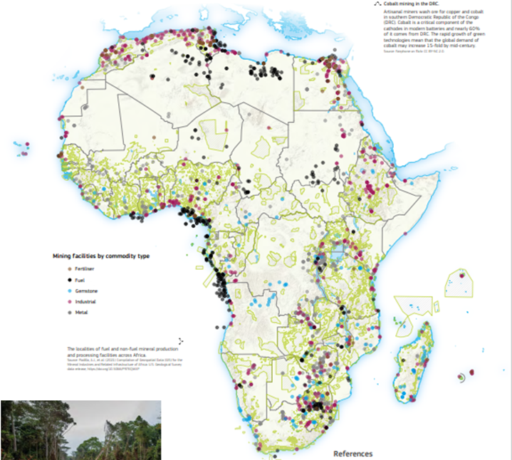

* + 1. Land use

According to the integrated assessment results presented in 3.1, the impact on land use is expected to raise by 5% in the current trajectory as analysed in JRC forthcoming, mainly due to the expansion of solar energy in the energy mix. The shift towards a sustainable and healthy diet, as well as reduction in energy consumption in housing through the renovation wave are found to be key potential measures for the reduction of these impacts.

Land management offers significant potential for **advancing EU climate and biodiversity objectives**. However, achieving these goals requires assessing trade-offs in land use to avoid unintended negative impacts.

**Land performs many vital functions**, supporting biodiversity and ecosystem services, including food production, pollutant filtration, natural hazard protection, and carbon sequestration. Changes to land use can thus have diverse impacts.

EU land use is shaped by **several anthropogenic drivers**: food and fibre production, biomass for bioenergy, carbon storage, expanding housing needs, and infrastructure development for mobility. Additionally, land use is influenced by indirect factors, including water needs, fertilizers, and pesticide use for biomass production, each carrying substantial environmental consequences.

"**Marginal lands**," often defined as underutilized or low-yield areas, represent a contentious solution for increased biomass production due to their multiple existing ecological benefits. Marginal lands have been defined in various ways (Shortall, 2013), which allows stakeholders to approach these areas as potential solutions for **different purposes** (). Primarily, they are considered for industrial biomass production using low-input systems (e.g., Scordia et al., 2022) that also improve soil carbon sequestration (e.g., Xu et al., 2022), reclaim saline soils (e.g., Sánchez et al., 2017), or remediate soils contaminated with heavy metals (e.g., Barbosa et al., 2015). Additionally, marginal lands are seen as a potential carbon mitigation strategy, functioning as carbon sinks irrespective of biomass output (<https://marginallands.eu/>).

Marginal lands are in part the result of land abandonment, i.e. land no longer in production, usually for economic reasons (Muscat et al. 2022). It is estimated that about 11% of the agricultural land in the EU (≈ 20.86 Mha) are under high potential risk of abandonment between 2015 and 2030 (Perpiña Castillo et al. (2018).

The main features and functions of marginal areas are summarised in box 1.

**Box 1.** Key facts and figures on EU marginal lands

* Total area: 606,747 km2 (60.7 Mha)
* The total carbon sequestration: 27,567,758 tC, which is 11% of the total in EU-27
* Marginal lands purify a total of 2,283,632 tonnes of water, which is 12% of the total in the EU-27
* The total soil retention in marginal land amounts to 1,253,944,192 tonnes, which is about 14% of the total soil retention services in the EU-27
* The pollination potential includes roughly 61,250 km2 of the total 606,747 km2 marginal lands.
* Marginal lands contribute to control flooding events, they offer opportunities for daily outdoor recreation activities and are suitable to support pollinator insects.

While marginal lands could potentially **provide local biomass**, with minimal competition against food production, altering their use may **reduce the ecosystem services** highlighted in the box. For instance, converting marginal lands to biomass plantations may boost carbon sequestration in the short term but could introduce emissions from land preparation and harvesting activities, impacting soil biodiversity and local ecosystem services. Moreover, the use of marginal lands overlaps with high-nature-value and forest areas, adding to the complexity of land use decisions.

In conclusion, land use change usually entails trade-offs between different benefits. Alterations to land should consider the pressures that will be put on the land systems (which include the environmental, social and economic dependencies on land), as well as the trade-offs in ecosystem services. It is important therefore, to study land use, land cover and land systems change from a holistic perspective to assess the full, and long-term, environmental implications of land use policies.

**Land use policies should prioritize a holistic, long-term perspective that balances the environmental, social, and economic pressures on land systems.** Ecosystem services—ranging from biomass and pollutant filtration to habitat maintenance—should guide land management, recognizing the multifunctionality of all land types. Marginal lands, in particular, require careful consideration to ensure they are not prematurely earmarked for production without assessing the full ecosystem service trade-offs they provide.

* + 1. Circular economy and climate mitigation

The Circular Economy (CE) contributes to climate change mitigation by redirecting the flows of the materials in the economy. In particular, it enhances the recirculation of material, enabling a cyclical flow of materials within a production and consumption systems. Drawing from scientific literature, the three main families of strategies enhancing material loops are:

i) reduction (narrowing the material loops by reducing demand, e.g. by demand reduction at production or consumption level);

ii) reuse (slowing material loops, by e.g. reuse or repair) and

iii) recovery (closing material loops, e.g. by recycling or other forms of recovery).

While reduction and reuse strategies (in all their possible forms), ultimately incur in a reduction of the overall material demand (primary and secondary), recovery strategies decrease primary material demand only under the assumption that a well-functioning market for secondary raw materials exists (i.e., secondary materials are absorbed by the market to displace primary materials).

The 2040 EU Climate Target Impact Assessment showed that around 25% of EU GHG emission reductions by 2050 relative to 1990 levels can be achieved through a more efficient use of resources in production, such as reducing demand for primary production by extending the lifetime of products, encouraging their sharing, reuse and recycling, and substituting primary raw materials with secondary raw materials[13]. In addition, by successfully applying EU waste legislation[14] across the EU27+UK, the cumulative reduction in GHG emissions could be up to 139 Mt CO2-eq. per year from 2035 onwards ([34]), i.e. 3.2% additional reduction relative to 1990 level. These could increase up to 171 Mt CO2-eq. per year, ca. 4% relative to 1990 levels, if even more ambitious waste legislation is enforced in the future ([34]).

More ambitious measures could further increase the potential of the CE to cut global emissions by 39%[15] and in the EU by up to 50%15,[16]. Other studies confirm these estimates or show an even larger potential[17]. For instance, Material Economics (2018) has found that up to 234 Mt CO2 eq. can be saved per year in the EU by 2050[18], when combining material recirculation, product material efficiency and circular business models and applying these to steel, plastics, aluminium and cement sectors across two major application segments (i.e., passenger cars and buildings). Demand-side measures could potentially contribute to more than half of emissions savings to net-zero and that, more often than not, the CE measures applied to the chosen sectors are economically attractive.

[35] assessed six different scenarios[19] with different levels of CE actions in the plastics sector – packaging, household goods, automotive and construction - representing ca. 75% of the total EU plastic demand in 2022. The authors estimated that the plastic 'circular scenario' can reduce GHG emissions by 67 Mt CO2-eq. in 2040. Reductions in the plastic sector GHG emission can reach up to 60% in 2050, relative to 2020. In their study, [36]focused on steel and concrete, concluding that the combined effects of CE actions for steel and concrete can bring an overall reduction potential of 130 Mt CO2-eq., a reduction of 61% relative to 2015. Furthermore, Zibell et al. (2022) investigated the impacts of hypothetical CE measures[20] across nine end-use sectors (textiles, construction, packaging, electronics, automotive, aeronautics, food, furniture and batteries) and five intermediate sectors (cement, steel, aluminium, chemicals and plastic) against a baseline scenario[21]. The study concluded that CE measures can save up to 509 Mt CO2-eq. per year on average in the period 2020-2050.

Therefore, implemented CE policies are anticipated to incur significant climate change reductions in the future, relative to a no-action scenario, however margins for improvement remain. It can be argued that the first strategy, material reduction at production level, may potentially be tackled in the context of energy efficiency and decarbonisation policies and company-driven process optimisation (at private sector level). However, behaviour-oriented demand reductions (by consumers) along with reuse and recovery strategies require appropriate interventions of the legislator, since benefits incurred at environmental (or societal) level most often do not correspond to economic benefits for the different actors involved in products (thus material) supply chain. Several examples could be made here, a prominent one being the externalised costs of waste management incurred by society, as exemplified by UNEP[22]. Correcting for these external costs or market failures requires measures that span across the entire material life cycles, from the design phase to use and end-of-life.

*Preliminary evidence shows significant additional potential of CE levers to mitigate GHG emissions in steel, aluminium, plastic and cement sectors*

The on-going JRC RecalibrateCE project aims to assess the impact of CE levers on the environment (pollution, resource use) beyond climate change, economy (e.g., investment and other costs, economic output, industrial competitiveness), and employment across four carbon intensive material sectors - steel, aluminium, plastic, and cement/concrete.

Preliminary results show that the *additional[23]* potential of the CE to mitigate GHG emission is significant. For example, enhancing scrap quality recovery, via improved collecting and sorting (to avoid export of low-quality scrap) can abate up additional 31 Mt CO2 –eq. per year relative to not-taking-action. Implementing more ambitious CE levers (a combination of reduction, reuse, and recovery) can abate GHG emissions by up to 104 Mt CO2-eq. per year, corresponding to an additional ca. 40% decrease of GHG emissions by 2050 relative to the GHG abatement that would be achieved purely from decarbonisation efforts. In the cement and concrete sector, reducing the use of clinker as well as the overuse of cement and concrete offer the highest reduction potential. About 27 Mt CO2-eq. per year can be avoided when implementing CE reduction strategies, whereas the total savings of implementing reuse and recovery strategies account for 37 Mt CO2-eq. per year. The combination of all CE strategies corresponds to an additional 37% decrease of GHG emissions by 2050, on top of the reduction stemming purely from decarbonisation efforts. In the aluminium sector, levers focused on recovery show the greatest reduction potential. Indeed, applying this bundle of levers would result in additional abatements up to 19Mt CO2-eq. per year relative to business-as-usual[24]. An additional abatement can be achieved when simultaneously implementing levers on reduce, reuse, and recovery (about 20 Mt CO2-eq per year), which corresponds to an additional 25% decrease of the GHG emissions by 2050, on top of the reduction related to decarbonisation only.

By reducing the final demand of plastic packaging and extending the life of plastic products and component (e.g. in construction and vehicles), there is potential reduction of 35 Mt and 25 Mt CO2-eq. per year respectively. At the end of life of plastics, by increasing recycling capacities and yields for chemical and mechanical recycling, GHG emission reductions of 23-30 Mt CO2-eq. per year can be obtained. Finally, by applying a combination of ambitious measures of plastic demand reduction, reuse and recycling, would result to 51% decrease of GHG emissions by 2050, on top of the reduction achieved by the anticipated energy decarbonisation efforts.

Annex

* + 1. Overview of the targets modelled in the Domestic Footprint Outlook

The inclusion in the various scenarios of the **18 targets** modelled in the DF is shown in Table 1 with additional detail provided in Annex 3 of [3]. It is worth noting that **3 targets** linked to the reduction in use of pesticides, **2 targets** for the reduction of air pollution and their impact on human health and ecosystems are assumed to be achieved in the **GTT** scenario, and **4 targets** linked **to reduction in nutrient loss, reduction in fertilizer use, land use change,** and **10 targets** linked to **climate neutrality** are included in the **GTT+** scenario. It is worth noting that the **No GTT** scenario may, or may not, achieve the targets that are included in the other scenarios due to the assumptions where No GTT follows past trend which show declining rates already in the historical data. For example, the continuation of trends in the impact category Acidification may be reached already in the NO GTT scenario.

Table 1. Modelled green transition targets in the Domestic Footprint.

|  |  |  |  |  |
| --- | --- | --- | --- | --- |
| **Modelled Target in Domestic Footprint** | **Status in** [13] | **Legally binding** | **GTT on Track** | **GTT ambitions** |
| Reduce by 50% the use and risk of chemical pesticides  *(Due to the large coverage of this target in different policy documents, it embeds the modelling of* ***3 GTT as detailed in* Annex 3** of [3]) | On track to be achieved | No | **X** | **X** |
| Improve air quality to reduce the number of premature deaths caused by air pollution by 55%. | On track to be achieved | No | **X** | **X** |
| Reduce by 25% the EU ecosystems where air pollution threatens biodiversity | On track to be achieved | No | **X** | **X** |
| Reduction of 55% greenhouse gas (GHG) emissions compared to 1990 levels  *(Due to the large coverage of this targets it embeds the modelling of* ***10 GTT as detailed in Annex 3*** of [3]*)* | Acceleration needed | Yes |  | **X** |
| Reach no net land take | No progress | No |  | **X** |
| Reduction of 50% of nutrient losses | Acceleration needed | No |  | **X** |
| Reduction of 20% of the use of fertilizers | Acceleration needed | No |  | **X** |

* + 1. Overview of the targets modelled in the Consumption Footprint areas of Consumption

The CF is a full bottom-up LCA model, meaning it relies on supply chain perspective which models the different life cycle stages (from extraction to end of life) of every product, to model the environmental impact of a unit of that product. Such value is multiplied by the annual consumption of a product which provides a macroscale perspective on the environmental impact of consumption. While the annual consumption are projected to 2030 with the method described in Annex 4 of [3], the LCA part of the model is also equipped with parameters that control the allocation of resources along life cycle stages, and can be varied to test different scenarios as well as uncertainties. For example, the production of food products requires certain quantities of pesticides per kilogram of output, which leads to the associated emissions to land as well as environmental impact due to the manufacturing and supply of those pesticides.

As a result, the modelling of the **NO GTT** scenario assumes the continuation of trends of annual consumption on the one side, while it considers the parameters controlling the environmental impacts in the LCA component of the models as non-influential to past performance, thus providing a reference condition in 2030 as if no green transition policy efforts were considered. These parameters are activated in the **GTT on track** and **GTT+** scenarios, thus describing the achievement of the selected targets presented that are detailed in the tables below and in Annex 4 of [3].

* + 1. Mobility

In the context of mobility, **3 targets** are considered, and are cumulatively included one per scenario (see Table 2). The achievement of targets on **advanced biofuels and biogas** in **GTT on track** scenario, and the targets on **sustainable aviation fuels** and the ambition of achieving **30 million electric cars on the road** is considered in the **GTT+** scenario.

Table 2. Modelled green transition targets in the Mobility Basket of Products of the Consumption Footprint.

|  |  |  |  |  |
| --- | --- | --- | --- | --- |
| **Modelled Target in Consumption Footprint** | **Status in JRC, forthcoming** | **Legally binding** | **GTT on track** | **GTT ambitions** |
| Each Member State shall set an obligation on fuel suppliers to ensure that: the combined share of advanced biofuels and biogas produced from the feedstock listed in Part A of Annex IX and of renewable fuels of non-biological origin in the energy supplied to the transport sector is at least 1 % in 2025 and 3,5 % in 2030 | On track to be achieved | Yes | **X** | **X** |
| Starting from 2025, at least 2% of aviation fuels will be green, with this share increasing every five years: 6% in 2030, 20% in 2035, 34% in 2040, 42% in 2045 and 70% in 2050. Hydrogen and fuel produced from cooking oil or waste gases considered green | No progress | Yes |  | **X** |
| There will be at least 30 million zero-emission cars and 80.000 zero-emission lorries in operation | Not considered | No (ambition) |  | **X** |

* + 1. Food

A total of **9 green transition targets and ambitions** are modelled in the food basket of products of the CF model. The **reduction in use of pesticides** (which covers 4 targets due to its presence in different policy documents) is included in the **GTT on track scenario**,and **6 targets** linked to **reduction in nutrient loss, expansion of organic farming, reduction in food waste, as well as the move to a healthier and more sustainable diet** ambition are included in the **GTT+** scenario.

Table 3. Modelled green transition targets in the Food Basket of Products of the Consumption Footprint.

|  |  |  |  |  |
| --- | --- | --- | --- | --- |
| **Modelled Target in Consumption Footprint** | **Status in** [13] | **Legally binding** | **GTT on track** | **GTT ambitions** |
| Reduce by 50% the use and risk of chemical pesticides  *(Due to the large coverage of this target in different policy documents, it embeds the modelling of* ***3 GTT as detailed in Annex 4*** of [3]*)* | On track to be achieved | No | **X** | **X** |
| Reduce the generation of food waste in processing and manufacturing by 10% in comparison to 2020 | Acceleration needed | No |  | **X** |
| Reduce the generation of food waste per capita, jointly in retail and other distribution of food, in restaurants and food services and in households, by 30 % in comparison 2020. | Acceleration needed | No |  | **X** |
| Increase organic farming with the aim to achieve at least 25% of total farmland under organic farming by 2030 | Acceleration needed | No |  | **X** |
| The losses of nutrients from fertilisers are reduced by 50%, resulting in the reduction of the use of fertilisers by at least 20%  *(Due to the large coverage of this target in different policy documents, it embeds the modelling of* ***2 GTT as detailed in Annex 4*** of [3]*)* | Acceleration needed | No |  | **X** |
| Move to healthier and more sustainable diets | Not considered | No (Ambition) |  | **X** |

* + 1. Housing

In the context of housing, **5 targets** and ambitions are considered (see Table 4). One target linked to the **use of renewable energy in buildings** was considered to be achieved in the **GTT on track** scenario, and **4 targets** that represent the ambition of renovation wave (i.e., **reducing final energy and heat energy consumption in buildings**, as well as **increasing the rate of expansion of energy efficient building until achieving deep renovation in 35 million building**) were modelled in the **GTT+** scenario. It is worth noting that the use phase (e.g. space heating) of housing represents the major hotspot for the environmental impact of buildings for livelihood, leading to the greatest opportunity for green transition at the EU level.

Table 4. Modelled green transition targets in the Housing Basket of Products of the Consumption Footprint.

|  |  |  |  |  |
| --- | --- | --- | --- | --- |
| **Modelled Target in Consumption Footprint** | **Status in** [13] | **Legally binding** | **GTT on track** | **GTT ambitions** |
| Member States shall determine an indicative national share of renewable energy produced on-site or nearby as well as renewable energy taken from the grid in final energy consumption in their building sector in 2030 that is consistent with an indicative target of at least a 49 % share of energy from renewable sources in the building sector in the Union’s final energy consumption in buildings in 2030 | No data | Yes |  | **X** |
| Reduce buildings' final energy consumption by 14% | Acceleration needed | No |  | **X** |
| Reduce buildings' energy consumption for heating and cooling by 18% | Acceleration needed | No |  | **X** |
| At least double the annual energy renovation rate of residential and non-residential buildings by 2030 and to foster deep energy renovations | Acceleration needed | No |  | **X** |
| Indicative national targets aiming to achieve the deep renovation of at least 35 million building units by 2030 to support reaching an annual energy renovation rate of 3 % or more for the period till 2050 | Not considered | No (Ambition) |  | **X** |

* + 1. Cross cutting: energy, transport, waste treatment, recycling and packaging

1. Table 5 shows the **20 cross-cutting targets** (i.e., targeting more than one basket of products in the CF). Due to the high importance of energy and circular economy for environmental impact 5 targets linked to energy expansion and recycling are considered as on track to be achieved, and included in the **GTT on track** scenario. Specifically, the changes in energy mix due to the expansion of renewable energy, with high promises for solar energy is a major driver of the impacts in the analysis of this scenario, as well as they impact all basket of products, and specifically in their production and manufacturing life cycle stages. On the other hand, the **GTT+** scenario also assumes the achievement of circular economy intervention which target the recycling of packaging made in plastic as well as sub-products (e.g., batteries in cars and phones), policies which influence landfill and incineration of wasted products, as well as further **expansion of renewable energy and** **wind energy** as part of the renewable energy mix**.**

Table 5. Modelled green transition targets in the energy, transport and waste treatment of the Consumption Footprint.

|  |  |  |  |  |  |
| --- | --- | --- | --- | --- | --- |
| **Modelled Target in Consumption Footprint** | **Basket of Products** | **Status in** [13] | **Legally binding** | **GTT on track** | **GTT ambitions** |
| Bring online over 320 GW of solar photovoltaic by 2025 and 600 GW by 2030 | Food, Mobility, Housing, Appliances, Household goods | On track to be achieved | No | **X** | **X** |
| Over this decade, the EU will need to install, on average, approximately 45 GW per year of PV to reach the share of 45% of energy coming from renewables set out in the RePowerEU Plan | Food, Mobility, Housing, Appliances, Household goods | On track to be achieved. | No | **X** | **X** |
| Recycling shall achieve at least the following targets for recycling efficiency:  […] No later than 31 December 2030 80% by average weight of lead-acid batteries. | Mobility, Appliances | On track to be achieved | Yes | **X** | **X** |
| All recycling shall achieve at least the following targets for recovery of materials. […] No later than 31 December 2031: (iii) 95% for cobalt, copper, lead, and nickel. | Mobility, Appliances | On track to be achieved | Yes | **X** | **X** |
| Recycling of aluminium in packaging: 60%  Recycling of ferrous metals in packaging: 80%  Recycling of glass in packaging: 75%  Recycling of paper and cardboard in packaging: 85%  Recycling of wood in packaging: 30% | Food, Appliances, Household goods | On track to be achieved | No | **X** | **X** |
| By 2030, the share of renewable energy in the electricity mix should double to 55-60%, and projections show a share of around 84% by 2050. The remaining gap should be covered by other low-carbon options | Food, Mobility, Housing, Appliances, Household goods | Acceleration needed | No |  | **X** |
| Energy demand to be covered by solar heat and geothermal should at least triple (currently rate at 1,5%) | Food, Mobility, Housing, Appliances, Household goods | Acceleration needed | No |  | **X** |
| Member States shall collectively ensure that the share of energy from renewable sources in the Union’s gross final consumption of energy in 2030 is at least 42,5 %. | Food, Mobility, Housing, Appliances, Household goods | Acceleration needed | No |  | **X** |
| The strategy sets targets for an installed capacity of at least 60 GW of offshore wind by 2030. | Food, Mobility, Housing, Appliances, Household goods | Acceleration needed | No |  | **X** |
| Recycling shall achieve at least the following targets for recycling efficiency:  […] No later than 31 December 2030 70% by average weight of lithium-based batteries. | Mobility, Appliances | Acceleration needed | Yes |  | **X** |
| Recycling or preparing for re-use 65% of all packaging waste by 2025, 70% by 2030  *(Due to the large coverage of this target in different policy documents, it embeds the modelling of* ***4 GTT as detailed in Annex 4*** of [3]*)* | Food, Appliances, Household goods | Acceleration needed | Yes |  | **X** |
| Reduce landfill to a maximum of 10% of municipal waste (by 2035) | Food, Housing, Appliances, Household goods | Not considered  (ambition) | Yes |  | **X** |

1. Climate change; Ozone depletion; Particulate matter; Ionising radiation; Photochemical ozone formation; Acidification; Eutrophication, terrestrial; Eutrophication, freshwater; Eutrophication marine; Water use; Land use; Resource use, fossils; Resource use, minerals and metals; Human toxicity, cancer; Human toxicity, non-cancer and Ecotoxicity, freshwater.
2. The planetary boundaries are represented by nine critical ecological thresholds: climate change, ocean acidification, stratospheric ozone depletion, biogeochemical flows in the nitrogen and phosphorus cycles, global freshwater use, land system change, erosion of biosphere integrity, chemical pollution, atmospheric aerosol loading.
3. The results linked to toxicity are subject to high uncertainty as specified in the classification and description of the Environmental Footprint (3.1) method EC (2021). Commission Recommendation of 16.12.2021 on the Environmental Footprint methods to measure and communicate the life cycle environmental performance of products and organisations. COM(2021) 9332 final.
4. [Ecodesign for Sustainable Products Regulation - European Commission](https://commission.europa.eu/energy-climate-change-environment/standards-tools-and-labels/products-labelling-rules-and-requirements/ecodesign-sustainable-products-regulation_en)
5. [Regulation - 2023/1115 - EN - EUR-Lex (europa.eu)](https://eur-lex.europa.eu/legal-content/EN/TXT/?uri=CELEX%3A32023R1115)
6.
7. The selection of targets for this IEA considered the following: 7 targets could not be estimated quantitatively, 35 did not relate to environmental aspects which are under the scope of the model, 47 could not be modelled due to a lack of product disaggregation in the model (e.g., cover heavy duty transport as part of the transportation of other products, but not specifically modelled as products themselves), 27 could not be considered as not covered by the Environmental Footprint indicators (e.g., overfishing), and 5 were deemed not relevant due to the timeline (e.g., new EUR7 requirements).
8. Additional details on the methodology adopted, approach to model scenarios and adaptations to the model are available in Pasqualino et al (2024).
9. The change towards a more sustainable and healthy diet was calculated with the EAT Lancet report from Willett, W. et al. (2019). Additional details on the modelling are available in Pasqualino et al. (2024). This is meant as a gradual shift from high consumption of animal based products such as beef, pork and dairy (that are known to have higher environmental impact per unit of consumption) to a diet based on vegetable based protein products, and higher consumption of vegetables in general.
10. The targets of expansion of organic farming as well as reduction in nutrient loss and fertilizers from soil were considered as not achieved in JRC forthcoming, and are also not legally binding. As a result, these were added as part of the EGD ambitious scenario in the IEA analysis.
11. The description of all the Environmental Footprint impact categories can be found at: <https://green-business.ec.europa.eu/environmental-footprint-methods/life-cycle-assessment-ef-methods_en>
12. https://www.wri.org/insights/how-mining-impacts-forests?utm_campaign=novrecap2024&utm_medium=bitly&utm_source=MonthlyRecap
13. Communication and Impact Assessment for the 2040 climate target.
14. Notably, the EU Waste Framework Directive 2008 amended in 2018 and the EC Packaging Directive 1999 amended in 2018.
15. Circle Economy, Circularity Gap Report, 2021
16. Ellen MacArthur Foundation (2019). Completing the picture: How the CE tackles climate change;
17. The studies and the estimates reported herein have been obtained via a literature review as part of the JRC RecalibrateCE project,
18. When compared with a 2050 baseline scenario, where no action is taken.
19. Six scenarios: a business-as-usual scenario without policy intervention; a ‘current policy’ scenario; a ‘circular scenario’(78% circular), a retrofit scenario (assuming retrofitting of current plastic production facilities with carbon capture and storage and renewable energy sources); a Net Zero Emission scenario.
20. Hypothetical CE measures classified as: i) reduction of the service level, e.g. smaller house; ii) reduction of the stock of assets (increase usage intensity, e.g., via longer life); iii) reduction of the flow of primary non-renewable materials – e.g., substitution of material by more efficient one, reduction of max, increased share on renewable material or recycled content).
21. Commission Communication COM(2018) 773 “A Clean Planet for all”: <https://ec.europa.eu/clima/system/files/2018-11/com_2018_733_analysis_in_support_en_0.pdf>
22. UN Environment Program (2024), Global Waste Management Outlook 2024. Available at: <https://wedocs.unep.org/bitstream/handle/20.500.11822/44939/global_waste_management_outlook_2024.pdf?sequence=3>.
23. *Additional* to what would result from the implementation of CEAP and from the contribution of the energy transition (including carbon capture and storage of hard-to-abate industrial emissions).
24. Business-as-usual scenario refers to the continuation of historic CE trajectory (with decarbonisation of energy)